**Thermal Calibrator**

The thermal calibrator is a support program for the purpose of providing accurate temperature calibration to the thermal detector by calculating a temperature offset from the user’s measurement.

***Note: the thermal calibrator should only be used if the temperature varies by a significant amount i.e. the thermal camera’s factory calibration is off.***

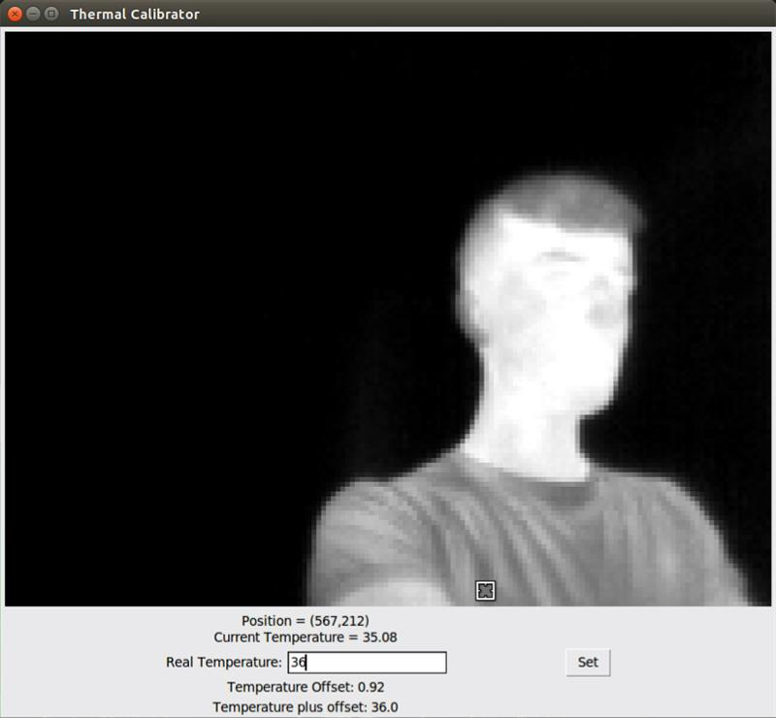

Figure 1-Program interface

The screenshot of the program interface is showed as above. The program requires the user to manually get a known target point temperature with their own device (such as a handheld infrared thermometer), then select it on the thermal video stream with the targeting cursor to get the uncalibrated temperature. Next, the user should input the correct temperature of the point. By clicking the “Set” button, the offset value will be calculated, shown to the user, and saved in the program working folder as a “dat” file which will be read by detector.py.

The program can take three parameters as described below:

-p --path Description: Relative path of thermal frame grabber to script working directory.

Default: thermal_grabber/build/thermal_grabber

-d --debug Description: Activate debug mode. Default: False

-ft --flipthermal Description: Flip thermal image 180 degrees. Default: False

To run the program, the “thermal_grabber” path must be provided.